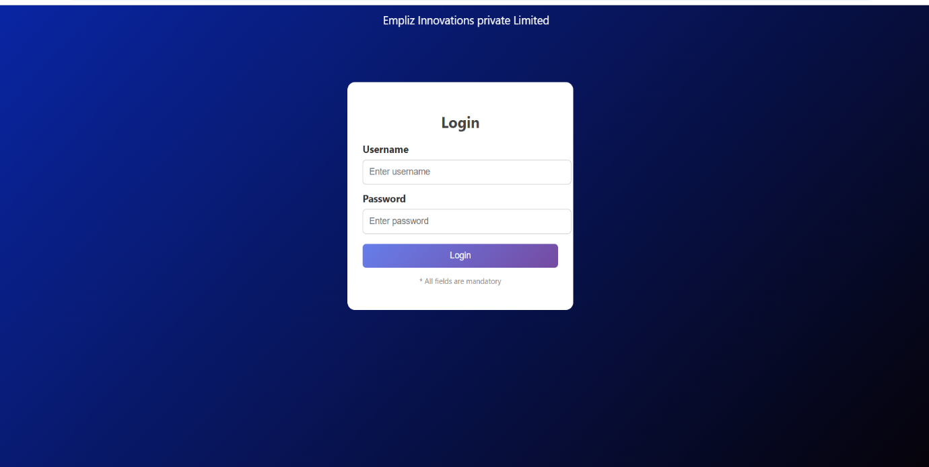
Fig:Login Form
This login form is designed using HTML and CSS to demonstrate basic web design concepts in a simple and structured manner. The form layout is created using HTML elements such as form, input, label, and button. A scrolling welcome message is displayed using the <marquee> tag to enhance user interaction.
The styling is implemented using three types of CSS:
- Inline CSS for individual labels,
- Internal CSS for headings and notes, and
- External CSS for overall page layout and form design.
Different CSS selectors are used, including element selectors, class selectors, ID selectors, and group selectors, to apply styles efficiently.

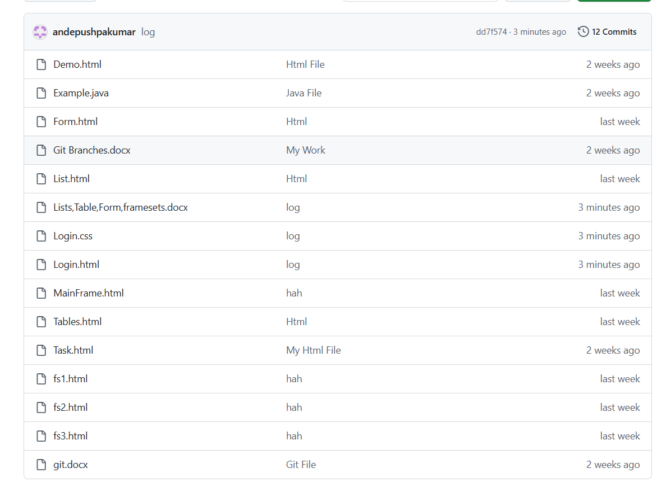
Fig :Git Repo

